mPokket App sentiment report

# Overall Summary

* App name: Slice
* Number of reviews analyzed is 61,922
* Total number of reviews after cleaning the data is 22,294
* Timeline of reviews: 1 January,2020 to 21 January,2021 (386 days)

## Comparison of Aspects depending on how many numbers of people are writing about the aspect.

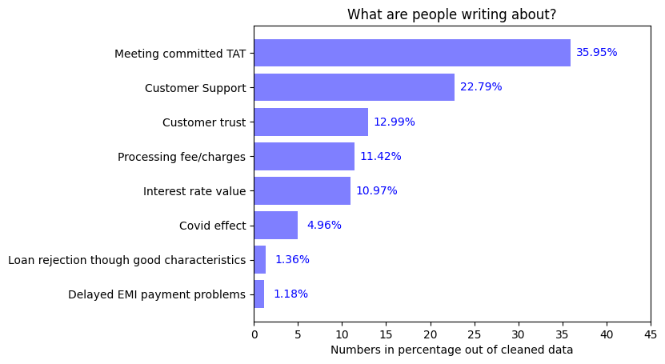

## Comparison of Aspects depending upon average rating given by users:

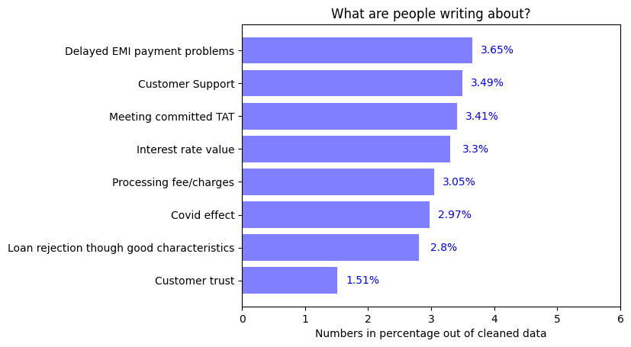

### Inference:

1. Large number of people are writing about meeting committed TAT and Customer support so these are important points from users’ perspective

# 1.Appropriate Interest rate

* Percentage of people writing about this topic is 10.97%



* Average rating given by users for this aspect is 3.30 out of 5
* 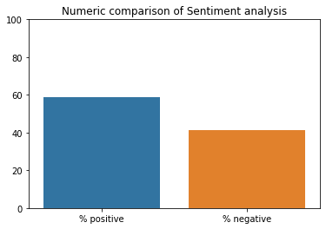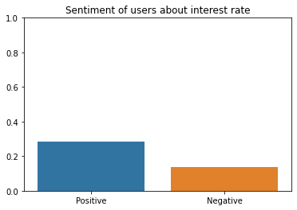Sentiment Analysis:

Figure 2: This shows how many people are positive or negative about this aspect

Figure 1: This shows Intensity of negativity or positivity of sentiments

### Inference:

1. People are more positive than negative about interest rate

Further Insights:

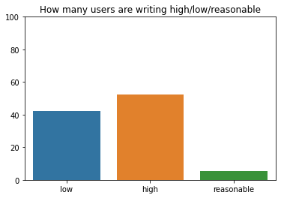

People saying interest rate is low =42.33%

People saying interest rate is high=52.38%

People saying interest rate is reasonable=5.28%

# 2.Delayed payments of EMI

* Percentage of people writing about this topic is 1.18%



* Average rating given by users is 3.65 out of 5
* 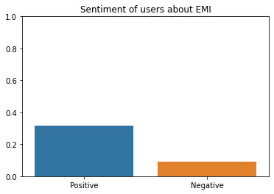 Sentiment Analysis:

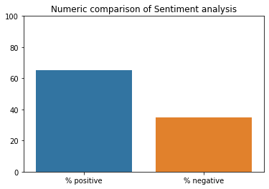

Figure 2: This shows how many people are positive or negative about this aspect

Figure 1: This shows Intensity of negativity or positivity of sentiments

### Inference

1. The overall sentiment of the users is positive
2. Very limited number of users have written about this topic

# 3. Loan rejection though good characteristics

* Percentage of people writing about this topic is 1.36%



* Average rating given by users is 2.80 out of 5
* 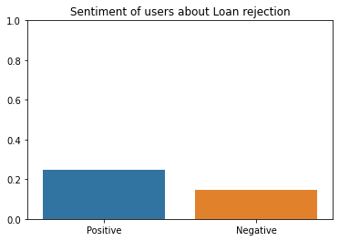 Sentiment analysis:

Figure 2: This shows how many people are positive or negative about this aspect

Figure 1: This shows Intensity of negativity or positivity of sentiments

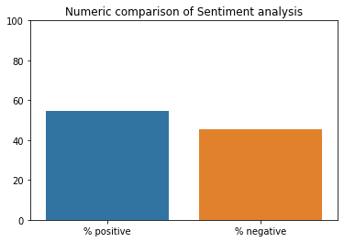

### Inference:

1. The sentiment of users about this aspect is positive
2. And, the number of users writing about this topic are also

# 4. Customer queries / grievances support services:

* Percentage of users writing about this topic is 22.79%



* Average rating for Customer support is 3.49 out of 5
* 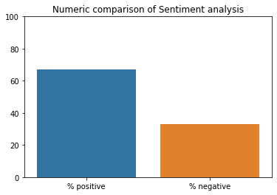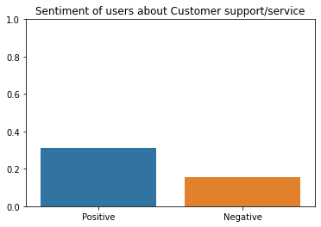 Sentiment Analysis:

Figure 2: This shows how many people are positive or negative about this aspect

Figure 1: This shows Intensity of negativity or positivity of sentiments

### Inference:

1. Users are more positive about Customer support

# 5.Processing Fee/ Extra Charges:

* Percentage of People writing about this topic is 11.42%



* Average rating for this topic = 3.05 out of 5
* f Sentiment:

Figure 2: This shows how many people are positive or negative about this aspect

Figure 1: This shows Intensity of negativity or positivity of sentiments

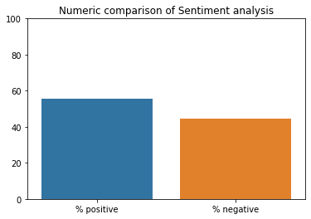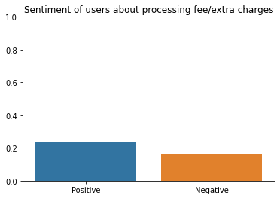

### Inference:

1. Users are satisfied with charges and along the industry standards

# 6. Loan disbursal to customer meeting the committed TAT

* Percentage of users writing about this topic is 35.95%



* Average rating by users is 3.41 out of 5
* 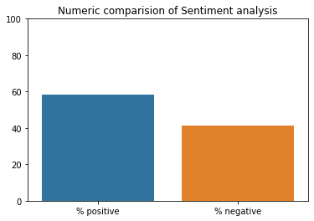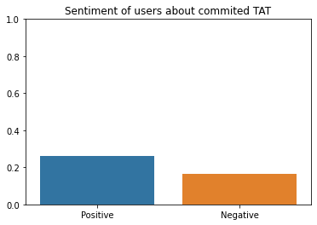Sentiment:

Figure 2: This shows how many people are positive or negative about this aspect

Figure 1: This shows Intensity of negativity or positivity of sentiments

### Inference:

1. Sentiment of users about TAT is mostly positive
2. Large number of users have written about it

# 7.Trust / legal/ fraud issues with app

* Percentage of users writing about this topic is 12.99%

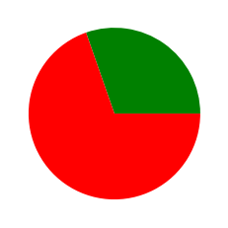

* Average rating by these users is 1.51 out of 5
* 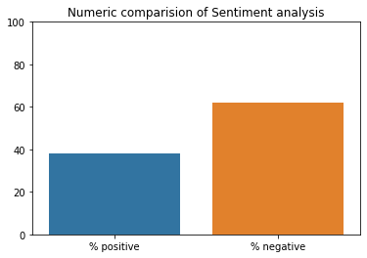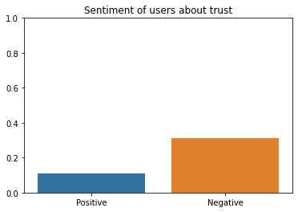Sentiment:

Figure 2: This shows how many people are positive or negative about this aspect

Figure 1: This shows Intensity of negativity or positivity of sentiments

### Inference:

### About 13% of users have written about trust on the app

### Out of which 60% users have suspicious view about the app while others are satisfied of its services

# 8.Covid-19 effect

* Percentage of users writing about this topic is 4.96%



* Average rating by these users = 2.97 of 5
* 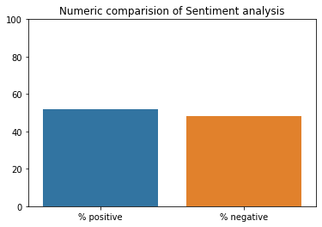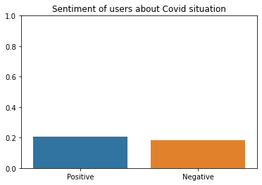Sentiment analysis:

Figure 2: This shows how many people are positive or negative about this aspect

Figure 1: This shows Intensity of negativity or positivity of sentiments

### Inference:

1. The services given by the app in covid-19 pandemic times have negative sentiment

### 